Recoverability in DBMS
A transaction may not execute completely due to hardware failure, system crash or software issues. In that case, we have to roll back the failed transaction. But some other transaction may also have used values produced by the failed transaction. So we have to roll back those transactions as well.
Recoverable Schedules:
- Schedules in which transactions commit only after all transactions whose changes they read commit are called recoverable schedules. In other words, if some transaction Tj is reading value updated or written by some other transaction Ti, then the commit of Tj must occur after the commit of Ti.
Example 1:
S1: R1(x), W1(x), R2(x), R1(y), R2(y),
W2(x), W1(y), C1, C2;

Given schedule follows order of Ti->Tj => C1->C2. Transaction T1 is executed before T2 hence there is no chances of conflict occur. R1(x) appears before W1(x) and transaction T1 is committed before T2 i.e. completion of first transaction performed first update on data item x, hence given schedule is recoverable.

Example 2: Consider the following schedule involving two transactions T1 and T2.

T1 | T2
R(A)
W(A)
 | W(A)
 | R(A)
commit
 | commit
This is a recoverable schedule since T1 commits before T2, that makes the value read by T2 correct.
Irrecoverable Schedule:
- The table below shows a schedule with two transactions, T1 reads and writes A and that value is read and written by T2. T2 commits. But later on, T1 fails. So we have to rollback T1. Since T2 has read the value written by T1, it should also be rollbacked. But we have already committed that. So this schedule is irrecoverable schedule. When Tj is reading the value updated by Ti and Tj is committed before committing of Ti, the schedule will be irrecoverable.
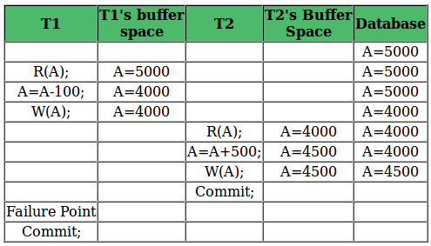

Recoverable with Cascading Rollback:
- The table below shows a schedule with two transactions, T1 reads and writes A and that value is read and written by T2. But later on, T1 fails. So we have to rollback T1. Since T2 has read the value written by T1, it should also be rollbacked. As it has not committed, we can rollback T2 as well. So it is recoverable with cascading rollback. Therefore, if Tj is reading value updated by Ti and commit of Tj is delayed till commit of Ti, the schedule is called recoverable with cascading rollback.
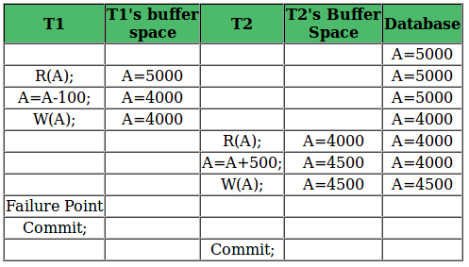

Cascadeless Recoverable Rollback:
- The table below shows a schedule with two transactions, T1 reads and writes A and commits and that value is read by T2. But if T1 fails before commit, no other transaction has read its value, so there is no need to rollback other transaction. So this is a Cascadeless recoverable schedule. So, if Tj reads value updated by Ti only after Ti is committed, the schedule will be cascadeless recoverable.
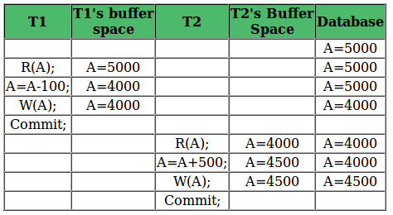

SERILIAZABULITY

A schedule is serialized if it is equivalent to a serial schedule. A concurrent schedule must ensure it is the same as if executed serially means one after another. It refers to the sequence of actions such as read, write, abort, commit are performed in a serial manner.

Example
Let’s take two transactions T1 and T2,
If both transactions are performed without interfering each other then it is called as serial schedule, it can be represented as follows −

T1 | T2
READ1(A)
WRITE1(A)
READ1(B)
C1
 | READ2(B)
 | WRITE2(B)
 | READ2(B)
 | C2
Non serial schedule − When a transaction is overlapped between the transaction T1 and T2.

Example
Consider the following example −
T1 | T2
READ1(A)
WRITE1(A)
 | READ2(B)
 | WRITE2(B)
READ1(B)
WRITE1(B)
READ1(B)

Types of serializability
There are two types of serializability −

View serializability
A schedule is view-serializability if it is viewed equivalent to a serial schedule.
The rules it follows are as follows −

T1 is reading the initial value of A, then T2 also reads the initial value of A.
T1 is the reading value written by T2, then T2 also reads the value written by T1.
T1 is writing the final value, and then T2 also has the write operation as the final value.

Conflict serializability
It orders any conflicting operations in the same way as some serial execution. A pair of operations is said to conflict if they operate on the same data item and one of them is a write operation.
That means

Readi(x) readj(x) - non conflict read-read operation
Readi(x) writej(x) - conflict read-write operation.
Writei(x) readj(x) - conflict write-read operation.
Writei(x) writej(x) - conflict write-write operation.

View Serializability in DBMS
Example : Understanding View-Serializability first with a Schedule S1 :

T1 | T2 | T3
a=100
read(a)
a=a-40
write(a) //60
a=a-40
write(a) //20
a=a-20
write(a) //0
So, its Conflict Precedence Graph is as follows –
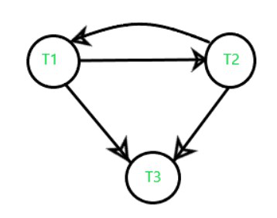
The above graph contains cycle/loop which means it is not conflict-serializable but it does not mean that it cannot be consistent and equivalent to the serial schedule it may or may not be.
LookSchedule S’1 :
In the above example if we do swapping among some transaction’s operation so our table will look like –

T1 | T2 | T3
a=100
read(a) //100
a=a-40
write(a) //60
a=a-40
write(a) //20
a=a-20
write(a) //0
Its Precedence Graph is as follows –
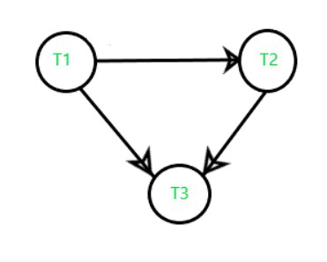
Now, we see that the precedence graph of the second table does not contain any cycle/loop, which means it is conflict serializable (equivalent to serial schedule, consistent) and the final result is coming the same as the first table.

Conflict Serializable check
Lets check whether a schedule is conflict serializable or not. If a schedule is conflict Equivalent to its serial schedule then it is called Conflict Serializable schedule. Lets take few examples of schedules.

Example of Conflict Serializability
Lets consider this schedule:
T1 T2
----- ------
R(A)
R(B)
R(A)
R(B)
W(B)
W(A)

To convert this schedule into a serial schedule we must have to swap the R(A) operation of transaction T2 with the W(A) operation of transaction T1. However we cannot swap these two operations because they are conflicting operations, thus we can say that this given schedule is not Conflict Serializable.
Lets take another example:
Lets take another example:
T1 T2
----- ------
R(A)
R(A)
R(B)
W(B)
R(B)
W(A)

Lets swap non-conflicting operations:
After swapping R(A) of T1 and R(A) of T2 we get:
T1 T2
----- ------
R(A)
R(A)
R(B)
W(B)
R(B)
W(A)
After swapping R(A) of T1 and R(B) of T2 we get:
T1 T2
----- ------
R(A)
R(B)
R(A)
W(B)
R(B)
W(A)
After swapping R(A) of T1 and W(B) of T2 we get:
T1 T2
----- ------
R(A)
R(B)
W(B)
R(A)
R(B)
W(A)
We finally got a serial schedule after swapping all the non-conflicting operations so we can say that the given schedule is Conflict Serializable.

